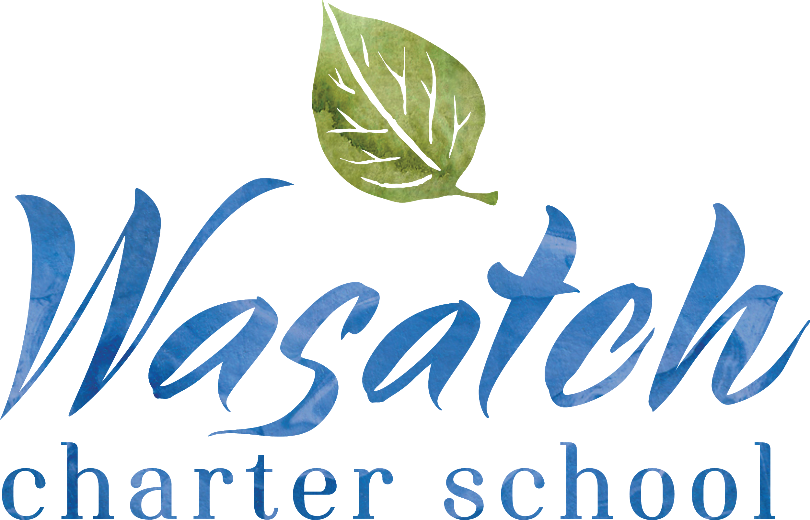

PARENT-STUDENT
HANDBOOK
2020-21 COVID SUPPLEMENT

STUDENT ATTENDANCE

Student Attendance and Work Requirements
Students will have access to online work if they are experiencing an extended absence from school.

This process of responding to individual student absences throughout the year will likely necessitate ongoing conversation, flexibility and trouble shooting.

For short-term absences, class teachers will work to make typical accommodations for students to make-up work, as needed.

When class teachers are out ill, parents will be notified and asked to engage in distance learning until the teacher is cleared to return to work. Other employee absences will be covered by available staff at school.

Covid Symptom Checking
Prior to coming to school, parents/guardians are responsible to check their student(s) for the following signs or symptoms:
  - Fever (temp greater than 100.4 or feeling chills/feverish)
  - Cough
  - Shortness of breath
  - Decrease in sense of smell or taste
  - Sore throat
  - Congestion or runny nose
  - Muscle aches/pains
  - Headache
  - Nausea, vomiting
  - Diarrhea

A child experiencing ANY of these symptoms must stay home and contact a medical provider.
Upon arrival to school, each student will be temperature screened and instructed to wash hands. If a student is found to have a fever at the temperature screening, their parents/guardians will be notified to come and pick up the child from school.

If a student arrives late, they will still need to complete the temperature screening and hand washing tasks.

Using an abundance of caution, if during the school day, any student presents with any of the symptoms listed above, they will be quarantined away from other students and staff (outside or in the nurses quarantine room) and sent home.

We are asking families to prepare for multiple ways to transport your child home and to pick up children from school as quickly as possible to prevent further spread. Ideally, we would aim for every student to be picked up within 20-30 minutes of receiving a phone call from the school.

If a student begins to exhibit symptoms while at school, teachers should send them to the nurse’s office off the atrium. Students with confirmed symptoms will be transported to a quarantine room to wait until a designated person comes to pick them up. The student will come home with instructions on how to proceed from there.

Kindergarten students who exhibit symptoms should be escorted to the nurses in the main building.

Lotus students who exhibit symptoms will be quarantined at the KinderHouse in the upstairs room. Parents and Deb will be notified that the student needs to be picked up.

Logs will be kept of all students visiting the nurses and / or being sent home.

Parents should consider what things students are checking in and out of school for. For example, if a student has a doctors appointment, consider keeping the student home for that entire school day. Teachers can help to discourage late arrivals / early pick-ups.

Frequently Asked Questions:

My student was sick and tested negative for COVID-19. When can they come back to school?
- Your student can return back to school after 3 days symptom free without the use of medication.
My student was sick and tested positive for COVID-19. When can they come back to school?
- Your student can return back to school after the following:
  - 3 days symptom free without the use of medication
  - 10 days after the first day of symptoms
- If you have other students that attend Wasatch Charter School, they will also need to stay home from school.
Someone in my student’s class tested positive for COVID-19. What happens now?
- Your student’s entire class will be put on a 14 day quarantine to ensure student and staff safety. You will be provided with instructions on how to proceed in the event that this occurs.
My child had a brief exposure to someone with a positive COVID-19 infection. What happens now?
- You will be notified with signs and symptoms to watch for and will be kept updated if there is new information.
What will happen if there is a huge spike in COVID cases when school starts?
- We will be cautiously and continuously monitoring the numbers of positive infections and working alongside the health department. The guidance has been to quarantine an entire class after 3 positive infections. Wasatch has decided to quarantine an entire class after 1 positive infection. If 15 confirmed cases occur within a small window of time, the school may start a distance learning only model for a period of time. The scope and extent of such a response will depend upon the breadth of spread within the school (not just number of cases, but number of classes / locations), the direction of the Health Department, and an evaluation of risk by the School’s Covid Team.
MODIFIED SCHOOL PROCEDURES
Restrooms & Hearths
- Restrooms will be used only by students in each designated hearth and overseen by hearth keepers.
- Students may only enter the restroom one at a time, and hearth keepers will ensure handwashing occurs after bathroom usage.
- Education will be provided and signage will be displayed in restrooms on proper hand hygiene.
- Proper airflow and ventilation has been reviewed related to building engineering.
- Locations in hearths will be designated for students to wait to use facilities.
- Hearth keepers will monitor access to soap and other sanitary products.
- Hearth keepers will use masks and gloves when preparing or serving food to students - no student contact with food (preparation, self serve, etc.).
- All linens (towels, etc.) will be washed daily.
- Disinfecting wipes, soap and water, or similar disinfectant will be available in hearths and use overseen by hearth keepers.
- Dirty linens or dishes will be placed in brown bags and then removed with proper PPE and sanitized daily.

Handwashing
- When students arrive at school, handwashing is required.
- Handwashing will also be scheduled into the day at several intervals, including before lunch and snacks.
- Instruction on proper handwashing procedures will be provided to all students.
- Hearth keepers will oversee handwashing upon entrance to the building and after restroom use.

Distancing and Face Coverings
- All faculty, staff, and students must wear face coverings, as described above.
- Class sizes are reduced, particularly in settings that are not the main classroom, to help support reasonable distancing.
- Students should have assigned seating that creates reasonable distance, to the extent possible given furnishings and classroom configurations. This is particularly true during seated work, lunch and snacks and other activities where distance may be reduced.
- Faculty meetings, parent meetings, and other events will maintain distance, require face coverings, as appropriate, and be held virtually when feasible.

Drop-off & Arrival
- Students will be dropped off to separate doors by grade and go directly to the appropriate hearth to wash hands.
- Doors are held open by staff or propped open in order to provide no touch entrance.
- Staff will take student temperatures (no touch) on arrival at doors before entrance.
- Symptomatic students (at the beginning of the day) will remain outside in the designated area. Students will wait near the garden at the picnic tables. A second temperature will be taken, and those who are still symptomatic will have parents contacted to come and pick them up.
- Traffic flow will be clearly designated for this time of day, such as walking on particular sides of the hallways or stairs.
- No parent access will be allowed in the building at this time.

Pick-up and Departure
- Kindergarten and first grade students are picked up earlier and separately from other students.
- Students will remain in classrooms during pick up time and be called down as their car arrives.
- As parents arrive, they will scan the QR code and enter their child’s information.
- Student information will populate a shared spreadsheet, indicating when their car has arrived.
- Two staff members and one traffic ninja will be assigned to each hearth to monitor the spreadsheet. As student names come up, those students will be retrieved from their classrooms and escorted to the front of the building by the traffic ninja / staff. Student names will then be crossed off the spreadsheet by staff.
- Students will be assigned to wait with their family / carpool in a designated parking spot until their car arrives at the front of the pick up line. Students will be required to maintain a distance and wait in the designated area until picked up.
- Assigned faculty will supervise pick up and car loading.
- No parent access will be allowed in the building at this time or at pick-up locations.
- Students in Grades 1-4 must be picked up at the school building (not the park or other off-site location), unless they live walking distance from the school and have pre-approved walking plans.
- Walking plans may be made for older students, if parents can ensure that distancing and behavioral expectations can be met.
- Pick up will commence at 3:00. Students with walking plans will be excused at 3:15.

Front Office & Common Spaces
- Front office will be accessed through windows only.
- Designated markings will be made on the atrium floor for students waiting for office support.
- Phone use is ONLY in the front office through windows (very limited access) -- no phone usage by students in classrooms. Phone will be sanitized between users.
- No drinking fountain use will occur. All students must have water bottles to fill up and use instead.

Making Payments
- No payments will be accepted in the office, in any form. All payments will need to be done remotely by credit card. School will set up online pages for any events/activities/donations/etc. that need payment, and will send links for those pages in emails to parents.
- School also has a Square account, and credit card numbers can be entered manually into the app without the card present. In unusual circumstances, a parent can call the office and give a credit card number to Deb over the phone, to make a payment.
- Lunch payments can be made online through Secure Instant Payments.

Lunch Service
- Lunch will continue to be served directly to students in classrooms.
- Food service workers will wear face coverings and gloves.
- Students will wash hands before and after meal services.
- Lunches will be served in compostable containers with lids.
- Food carts will be cleaned and disinfected regularly.
- Daily lunch pick-up will be provided for online students from 11:30-12:30.
- Dirty silverware must be placed in brown paper bags that will be collected for sanitation at the end of lunch service.

Computer Usage
- Computers will be sanitized before and after each use.

Lost & Found
- Lost and found items will be placed in brown bags in each hearth. They will not be available to students to look through.
- Hearth keepers will place brown bags in the larger bins at the end of each day. Bins will be placed in a secure location and not be available to students.
- Items will be collected throughout the week and then sorted by volunteers (using appropriate PPE) at the end of the week. Items that are clearly marked with student names will be returned. Other items will be recorded by picture and listed on the Family Council portion of the school website. Parents may look for missing items and contact the Lost and Found Committee to request their return.
- Items unclaimed for four weeks will either be donated or stored for the School’s Rummage Sale.

Visitors / Parents
- Visitor and parents access to the building will be substantially limited.
- To check a child out, parents must call the office. The child will be called down and meet the parent at the front door outside of the building. A child will be released only when their parent is in line of sight from the office.
- Any volunteers or other approved visitors must be arranged in advance with Deb. These individuals will be allowed to enter the building only at the designated time for their volunteer or other approved activity.
- Visitors and volunteers approved for entrance will be required to have temperature checked, complete a symptom checklist, and wash hands when checking in at the window to the Front Office.
- Visitors and volunteers will be required to wear face coverings while on campus.
- All IEP meetings will happen through video conference.
- Support Circles and other parent meetings will happen primarily through video conference, and in-person, as needed when larger meeting spaces are available.
- Access to the KinderHouse will be limited. Parents needing to pick up children early should coordinate directly with teachers, but should limit these occurrences as much as possible.

Class Trips / Field Trips
- No Fall class trips will occur. Spring trips may be scheduled if we have transitioned to Green.
- Field trips that require transportation will not be held until the designated Risk Level is Green.

School Gatherings / Assemblies
- No large assemblies will be held: weekly Friday “virtual assemblies” will be shared online.
- Festivals will be modified to limit group size and keep only individual classes in contact.
Safety Drills
- Modifications will be made for evacuation protocols in order to limit large group gatherings during drills.

Monitoring for Incidences
- Families will be provided with a guide to assist them in conducting symptom checks at home.
- Families who need access to thermometers, or other items, as-needed to fulfill appropriate symptom checking requirements will be supported.
- Staff/student symptoms and absenteeism will be carefully monitored; staff and students will be educated that “If you feel sick; stay home.”
- Students exhibiting symptoms during the school day will be quarantined in the nurses’ office, required to wear face masks and sent home.
- Faculty and staff exhibiting symptoms during the school day will be required to leave the building.
- Symptomatic students and staff will be encouraged to be tested for Covid and will not be allowed to physically return to school until they meet the criteria listed above and / or are cleared by a medical provider.
CLASSROOM & BUILDING CARE
Cleaning Regimen
- The school will acquire sanitation equipment for both bathrooms and surfaces prior to school re-opening.
- Restrooms will be cleaned at scheduled intervals during the day. (Custodial Crew Oversees)
- High-touch areas (e.g., faucets, paper towel dispensers, door handles) will be cleaned at scheduled intervals throughout the day. (Custodial Crew Oversees)
- Classrooms will be cleaned at the end of each school day. (Teachers Oversee)
- Common areas and surfaces will be disinfected daily. (Custodial Crew Oversees)
- PPE (gloves, masks) will be available for staff providing support in restrooms, including custodians.
- Training will be provided for proper cleaning protocols for COVID-19.

Classroom Requirements
- Hand sanitizer will be available in classrooms.
- Disinfectant spray and disposable towels and gloves will be provided to every classroom.
- Individual student supplies are maintained and stored separately.
- All students have assigned hooks in cubbies / seats in classrooms.
- All tables and benches / stools will be sanitized at the end of each day.
- Teachers and hearth keepers will clean and disinfect frequently touched surfaces and items at least daily (doorknobs, desks, computers, sporting equipment, shared supplies, etc.).
- Clean frequently touched items daily and any shared supplies.
- Limit or eliminate soft cloth surfaces such as rugs and couches.
- If using cushions for seating, ensure they are assigned to individual students and stored away from each other -- consider fabric-safe and effective spray for treatment at the end of each day.

Air Flow & Ventilation
An analysis of the HVAC system and consultation on appropriate AND effective mitigation strategies has been obtained.

This documentation from an extensive review of over 80 scientific studies and research states: “The Center for Disease Control and Prevention (CDC) in their webpage “How COVID-19 Spreads” states that droplets are the primary means of transmission and it does not even mention airborne or aerosol transmission. WHO states in their current scientific brief: “According to current evidence, COVID-19 virus is primarily transmitted between people through respiratory droplets and contact routes. In an analysis of 75,465 COVID-19 cases in China, airborne transmission was not reported.” A report from WHO-China stated “Airborne spread has not been reported for COVID-19 and it is not believed to be a major driver of transmission based on available evidence.”... In addition to investigating airborne transmission and the impact of dilution ventilation, we searched the literature for evidence of diseases being transmitted via recirculation through air handling systems. Surprisingly, we found few that even addressed the possibility and none that demonstrated recirculation from air handling systems caused any infections of any disease, not just COVID-19.”

While the conclusion of experts is that there is little risk of aerosolized spread and that HVAC alterations are minimally effective, particularly for new buildings meeting higher building codes (such as ours), the following steps will be taken to improve air flow, which can help mitigate the risk of Covid transmission.
- Doors to classrooms / offices and windows should be left open when classrooms are in use. (The exception to this practice would be quarantine spaces.) There should be two points of entry for air flow.
- Opening windows are being secured for rooms where they are unavailable.
- Teachers should ensure that HVAC vents are not being blocked or screened by paper, cloth, etc.
- HVAC system will be services, and higher grade filters secured.
- Effective air purifiers will be procured for use in spaces regularly used for student instruction that do not have exterior windows.
- Outdoor classroom spaces will be set-up and available for teacher use, as appropriate, particularly vigorous activities, such as singing, loud speaking, and movement where more droplets are created / secreted.
- The HVAC system will be running prior to people occupying the building again (done -- it was not turned off for summer) and it will run continuously, not allowing individuals to turn off circulation to specific rooms or zones (also done, our system does not allow that type of control). [Suddenly, what we have complained about for years is a blessing.]
CLASSROOM PRACTICES
Student Mask Use
Student’s masks must comply with the following standards.
- Fit over and cover both nose and mouth well
- Follow our Wasatch Charter School dress code policy (patterns, plaids, stripes, solids, no words, logos etc.)
- If using cloth masks, cleaned and sanitized at home after each day of use. We recommend that you consider buying one mask per school day in the week for your student(s).
- We have a small number of masks to give to students. Since our supply is limited, we are strongly encouraging parents to ensure their student has masks accessible to them. In our search, there are several options available at common retailers like Target and Amazon.
- Neck Gaiters or Bandanas will not be acceptable masks for school.
- Wasatch Charter School will be providing each student with a lanyard to attach to their mask in order to decrease the amount of missing or lost masks. The lanyard will stay at school each day.
- An example of an acceptable mask is:
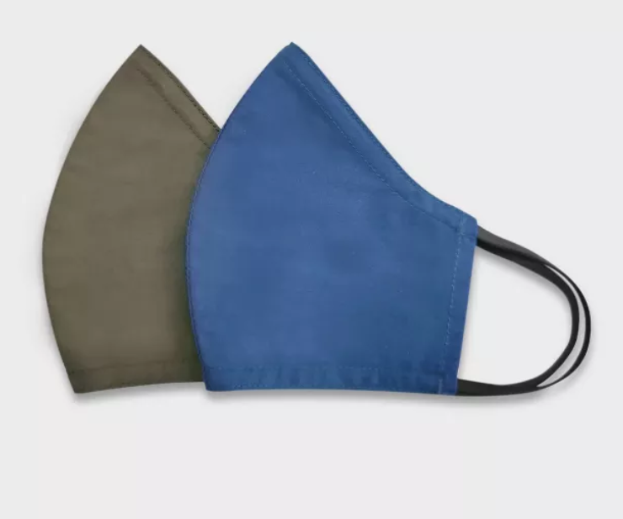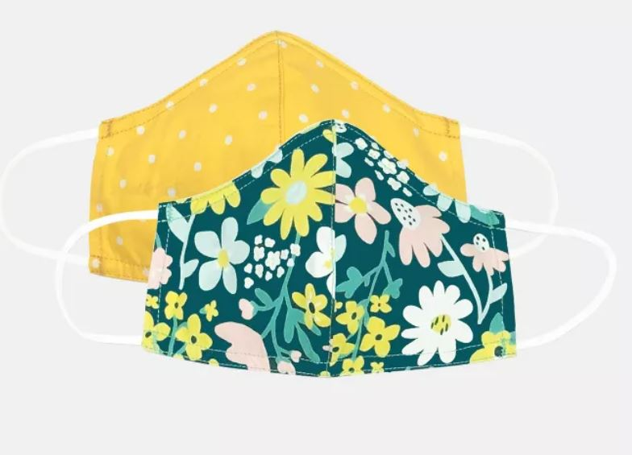
There are valid concerns with the duration of mask wearing throughout the day. We also realize that it is impossible for the students to wear masks during some activities like eating, small group reading instruction or speech therapy. During instructional times when mask use may be limited, other means of PPE will be used by those who are able in the room (i.e. speech therapist wears see through face shield during session.)
Each classroom teacher will need to consider their day and ensure that students get mask breaks throughout the day in addition to other times when students cannot wear a mask. During these times, teachers must ensure that students are physically distant from others.

The times when masks will be removed will be the following:
  - During snacks and mealtimes.
  - Outside during designated mask break time with teacher supervision when physical distancing can be maintained.
  - Possibly during small group reading and speech therapy sessions. *During this time, other safety measures will be in place.
Face Mask FAQs
Who needs to wear a face covering?
Based on the Governor’s State Public Health Order and the requirement of the County and Health Department, All faculty and students are required to wear face coverings at school. COVID-19 can spread between individuals in close proximity through respiratory droplets produced when an infected individual speaks, coughs, or sneezes. Please choose a mask that follow dress code guidelines.
When are masks expected to be worn?
During drop-off and pick up times and when waiting in line to enter the building.
Always inside the building (except in designated situations, listed above / below).
During recess.
When are masks NOT required?
The rules do not apply to outdoor settings where social distancing is easily maintained under teacher supervision. Masks will be worn during recess.
When drinking and eating and social distancing is maintained.
During some instructional activities under the supervision of an instructor, speech therapy and small group readings where other safety measures will be taken. Including face shields, specific masks with windows, other barriers.
Are there any exceptions?
Yes, but only for those individuals with conditions where a face covering would be considered harmful or a child who has a disability and is unable to maintain mask use. This should be communicated to and coordinated with the School Nurse.
According to the State Public Health Order for masks in schools: "A school may require an individual to provide a medical directive verifying a need for an exemption". An exemption form will need to be filled out by parents with medical documentation to support accommodation. This form should be given to the school nurse who will write an individualized health plan to support an accommodation.

If I, or my student, have a health or respiratory disease (i.e. Asthma) should a mask be worn?
It is important to work with your primary care provider in determining what steps should be taken to ensure safety. Anyone who has underlying respiratory disease and might be concerned about whether they would have a problem wearing a mask or facial covering should get in touch with their health care provider. This should be communicated to and coordinated with the School Nurse.
What face coverings are acceptable?
Cloth Covering and surgical masks
Do I need to wear a mask if I am not sick?
Both asymptomatic and pre-symptomatic (infected but not yet symptomatic) carriers can be contagious. 35% of people with Covid-19 DO NOT have symptoms.
Do I have to wear a mask if I have already had Covid-19?
Yes. All individuals in the school will be required to wear masks. A study at King’s College London showed that antibody levels (represents a level of immunity to reinfection) dropped after 3 months. A significant percentage of individuals who recover from Covid-19 are vulnerable to contracting it again.
Why do I wear a mask if I am social distancing?
The National Academy of Science showed that a combination of physical distancing and mandated mask-wearing was more effective than doing either one alone.
Does a mask only protect others, or does it protect the person wearing it?
Essentially, wearing a mask decreased the amount of virus you take in if you’re exposed to an infected individual. What we know about Covid virus is that the more exposed you are to it, the sicker you’re likely to get.
Who is responsible for providing face coverings?
Ideally all individuals (students, staff, faculty, and visitors) would acquire a face covering that meets the above standards allowing for personal preference and appropriate fit. Consider practicing wearing a mask with your student before school begins. Multiple face coverings should be acquired to facilitate washing between use (one clean for school while a second is being washed.)
The school will provide a disposable mask if anyone arrives at school without a mask.
How will mask use be implemented?
Time will need to be taken in all classes at the beginning of the year to discuss the norms and expectations for mask use. Students will be reminded to use masks, as needed. For particular students who may find this requirement challenging, teachers and support staff will work with parents to identify appropriate accommodations and strategies for support.
What is the consequence if a student refuses to wear a mask?
Mask use is not optional. Students may struggle with this requirement, and teachers and staff will offer kind and gentle reminders, as needed, and schedule breaks. If a student refuses to wear a mask, it will be seen as a disciplinary matter and subject to the same types of consequences as other behaviors, including suspension and expulsion. If a student is consistently struggling with this requirement, including as a result of a disability, a meeting will be arranged with parents in order to identify ways in which the student’s learning plan may be modified to ensure this safety standard is met.
SUGGESTIONS FOR PARENTS
- Have multiple cloth face coverings, so you can wash them daily and have back-ups ready. Choose cloth face coverings that
  - Fit snugly but comfortably against the side of the face
  - Completely cover the nose and mouth
  - Are secured with ties or ear loops
  - Include multiple layers of fabric
  - Allow for breathing without restriction
  - Can be washed and machine dried without damage or change to shape
- Label your child’s cloth face coverings clearly in a permanent marker so that they are not confused with those of other children.
- Practice with your child putting on and taking off cloth face coverings without touching the cloth.
- Explain the importance of wearing a cloth face covering and how it protects other people from getting sick.
- Consider talking to your child about other people who may not be able to wear cloth face coverings for medical reasons (e.g., asthma). This may help with understanding if there is a child in class or at school for whom a mask exemption is in place.
- As a family, model wearing cloth face coverings, especially when you are in situations where physical distancing is difficult to maintain or impossible.
- If you have a young child, help build their comfort wearing a cloth face covering and become comfortable seeing others in face covers.
  - Praise your child for wearing a cloth face covering correctly.
  - Put a cloth face covering on stuffed animals.
  - Draw a cloth face covering on a favorite book character.
  - Show images of other children wearing cloth face coverings.
  - Allow your child to choose their cloth face covering that meets any dress requirements your school may have.
  - Suggestions from the American Academy of Pediatrics

Restroom Use
Only one student at a time may be in any restroom. Teachers and hearth keepers should help enforce this standard. Locations will be marked on the floors of the hearths to help guide students as to where to wait to use the restroom or wash hands at the sink.

More than one student may be in the restroom at a time during handwashing times, so long as there is adult supervision.

Areas for Instruction
- Handwashing (consider using a stamp or marker with young children to help guide them on how long to wash. Train up on how to handwash efficiently before lunch and snacks. Use bathroom sinks and hearths and have adults supervise. 1st and 2nd grades have two sinks in each classroom plus two in the hearth.
- Restroom use: one at a time, wait on designated spots, wash hands in hearth when finished.
- Physical spacing in halls, lines, and classrooms.
- Walking in the hallways and up the stairs on the right hand side.
- Walking paths in classroom: one way through cubbies, how to distribute supplies, etc.
- Mask wearing expectations, including not touching face, how to take off and put on, lanyard use for mask breaks.
- No playing on handrails.
- No elevator use, unless for physical or health condition.
- Recess expectations.

Student Grouping and Tracking
- Teachers must assign seats for students. Please create a seating chart that can be used if contact tracing is needed.
- Teachers may think about creating smaller cohorts (2-4 students) within the classroom and for moving around through the day. These groups can sit near each other, eat lunch with each other, and play together at recess.

Attendance & Tardies
Teachers MUST take roll daily in order to support contact tracing. All attendance, including for online students, should be entered into Aspire. Students will no longer be bringing tardy slips into the classroom. In order to not mis-report for a day, attendance should be taken between 9-3. Attendance calls will be going out to parents at 4 PM.

Supplies
Students should be assigned their own:
- Hooks in the cubbies
- Seat in the classroom, including cushions
- Supplies that are separated and designated for each student to use their own each time

Recess
Typical recess rules are still in effect. However, in addition, it should be noted that:
- Specialty teachers and assistants will supervise recess.
- Classes will be assigned a designated space for recess and should remain there (these will rotate over the course of the week). Classes should not mix during recess time.
- Students will be expected to wear masks at recess.

Teachers that are interested in having class equipment for recess should coordinate with Mr. Keenan. Shared supplies will no longer be provided for recess and gym equipment will not be available for check-out. Recess equipment should be sanitized after use when brought into the classroom.

Snacks & Water
Students will still need to bring snacks to school. If snacks are donated by parents, they should be stored in the hearth, not in the classroom. Hearth keepers may still prepare / distribute snacks, if:
- They have food handlers permits.
- No children are allowed in the kitchen to prep or eat.
- They wear a mask and gloves.
- They serve the students individually and do not have community plates / pots.
- Dirty dishes are promptly washed and disinfected in the dishwasher.

Students will need to bring a water bottle to school clearly marked with their name (on the top or side, not on the bottom). Water bottles will be available in the Hearth for students who forget theirs from home. They can be used during the day and then need to be returned to the hearth and placed in the brown bag for dirty dishes so they can be washed and sanitized and reused.

Transitions between Classes
- High traffic areas will be identified and traffic flow will be clearly designated, such as walking on the right side of the hallways or stairs.
- Teachers should coordinate transitions between classes to reduce congestion in hallways. This is as simple as being aware of when / where there is a lot of activity in the hall or on the stairs and either waiting a couple of minutes or taking another path.
- Students are expected to be spaced out in line, walking silently in the halls, and stay with their class when transitioning.
- ALL classes, including middle school classes, should be escorted to and from class -- no students released on their own between classes. For Middle School Electives, this means that teachers should collaborate on a process to ensure that students have a designated place to gather and a designated adult to escort each group to / from class.
- For students in intervention / SPED services, exceptions may be made for older students to travel in halls alone. This will be overseen by the Hearth Keepers and other personnel.
- Doors will be propped open or held by a designated individual in order to reduce touch.
- High-touch surfaces in rooms used by multiple classes will be cleaned between specialty classes or intervention / SPED services.
- Students should sanitize hands on the way into and out of any specialty classes that occur outside of their classroom.
- Surfaces used during specialty classes or small group instruction that will be used by other students (such as music stands, computers, tables, manipulatives, etc.) should be sanitized after each class by the teacher or older students who have been trained.

Indoor Shoes
Indoor shoes will not be universally requested at the beginning of the school year, but will be essential when the weather begins to change. Teachers should consider methods for storing outdoor shoes in the classroom, and changing shoes in the classroom, rather than in the hallways to reduce student mixing in hallways. More details will be worked out in the coming months as processes settle. Teachers may request indoor shoes for their individual classes, if desired, but a method must be developed for safely changing and storing the shoes.

Phone Use
Students are not allowed to use phones in classrooms. Phone calls should be substantially limited to true emergencies only and must be made from the front office. A student coming to use the phone should bring a note from the teacher.
ONLINE LEARNING
In the coming year, all students will be engaged in remote learning for at least one day of the week.

When engaged in remote / online learning students will be expected to:
- Attend class every school day; attendance will be taken,
- Complete assigned work in the appropriate period of time,
- Use school resources and supplies appropriately and care for them well,
- Use school-issued computers and electronic resources exclusively for school work and as outlined in the School’s Electronic Use Policy.

Google Classroom
- Every Class Teacher will have a Google Classroom. These will be linked on the class webpage on the new website, and students will be provided with appropriate login information.
- Specialty teachers will provide content for lower grades on their overall google classrooms, for the older grades, specialty teachers will have their own Google Classrooms (particularly for Spanish and Strings) -- these will to be linked from the Class Teacher's Google Classroom.

Class Websites
Every class has its own website on the new website.

Websites may have the teacher’s bio, a link to the class’s Google Classroom, links to other online platforms that students may need to access or specialty teacher’s Google Classrooms (for upper grades) and general information about the class. In addition, teachers may choose to use the website to share newsletters and information for parents, as well as other purposes. Logging into each class’s website will require a password.

Online Students (4 and 5 Days)
Students whose learning plan is for 4 or 5 days online will continue to be served fully by school staff. Learning experiences will be shared via online platforms, but will seek to find an age-appropriate balance between learning activities that require computer access / screen use and those that can be completed without.

Online teachers will be the teacher of record for any students who are learning remotely 4 or 5 days a week. Online teachers will:
  - Take attendance daily
  - Provide meaningful instruction
  - Assign student work
  - Track student assignments & progress
  - Respond to parent and student requests or concerns
  - Complete parent conferences & report cards
  - Check in on students who may be struggling to participate, not making progress, or have other specific needs
  - Make referrals to SSEG, as needed

Online only middle school students will be able to sign-up to participate in Friday electives.

Friday In-person Classes
Class teachers are responsible for Friday instruction in person within their grade teams. Teachers will divide the instruction for Fridays based on what feels the most supportive to colleagues and the students. Students learning online 4 days a week and attending school on Fridays (or the final school day of the week)

Friday Online Classes
Class teachers are responsible for their online content for their classes for every Friday. Friday work will be simple: follow-up / wrap-up main lesson work for the week, practice in math / language arts using online platforms, specialty classes.

Online teachers are responsible for the 5 day remote students content on Fridays, but it will look similar.
STUDENT HEALTH & NURSING
Typical Health Concerns
Students needing support for typical concerns, such as bumps and bruises, should receive care in the classroom or hearth. Class teachers and hearth keepers will be provided with supplies for addressing these situations. Hearth keepers will be trained to assess and respond to minor student issues. The 3-4 Hearth Keeper is a CNA will be serving as our back-up nurse this year, and may be able to offer support for more challenging situations.

Nurse Jen and Nurse Kate will come to come assess a problem, if needed. They will also come directly to the hearths for medication administration.

Children who do not have Covid symptoms should be served in the hearths and classrooms, not sent to the office of the nurses.

QUARANTINE & SCHOOL CLOSURE
Tracing and Quarantine
School attendance data will be essential in engaging in effective contact tracing.
Should there be an individual who has been attending school (faculty, staff, or student) who tests positive for Covid-19, the School and the Health Department must be notified.
Based on contact tracing, school nurses (who are our Covid Points of Contact for families and the Health Department) will work with Administration and the Health Department to determine the level of exposure.
In general, the School will determine who has had high exposure (more than 15 minutes and possibly not at a distance) or brief exposure (less than 15 minutes and / or distanced).
All individuals determined to have high exposure will be notified and instructed to quarantine for 14 days. At Wasatch, high exposure will automatically include:
- any classmates of a student who has tested positive,
- any class teacher of a student who has tested positive
- any students of a class teacher who has tested positive
- any students who attend a small SPED or intervention group with a student or teacher who has tested positive
- any sibling or family member of a staff member or student who has tested positive
High exposure may also include any other individual who has been found to have spent over 15 minutes in close contact with an infected individual. *This is why maintaining records will be essential. In addition, this is why we are working to structure days and routines in such a way that we dramatically minimize any extensive contact between students in different classes.
Those individuals who are determined to have had brief exposure will be notified to watch for symptoms, and instructed to inform the school if they manifest symptoms, but not required to quarantine, as the actual risk of infection is very low.
When will a student or staff member be quarantined?
Anyone who has been in close contact with someone who has Covid-19 will be asked to quarantine. Close contact includes, being within 6 ft for 15 minutes, experienced direct contact, shared eating/drinking, or directly sneezed or coughed on. At school a student will be sent placed in isolation and parents called to take home if they have:
- Fever
- Fever and 1 symptom (see symptom screening form)
- 1 symptom and exposure
- 1 symptom and waiting for a test result

What will students need to do during Quarantine?
Students will be asked to stay home, separate themselves from others, and have their health status monitored. Monitoring for signs and symptoms including; fever over 100.4, cough, and respiratory symptoms. Students should seek medical care if symptoms worsen or if they develop emergency respiratory complications.
Why may we be asked to be quarantined?
Our goal is to keep everyone safe by keeping someone who might have been exposed from Covid-19 away from others. Quarantine prevents spreading that can occur before a person knows they are sick, or are infected with the virus without having symptoms (asymptomatic).
How long should individuals stay quarantined?
Based on the CDC’s current recommendation, we will require a 14 day quarantine. This means 14 days after the last contact with the individual infected with Covid-19.
Individuals should remain home after the 14 days, if they have any symptoms or tested positive for Covid themselves.
Why 14 days?
We know that signs and symptoms of Covid-19 appear 2-14 days after exposure.
What if another family member has suspected Covid or if my student is exposed again during quarantine?
The 14 day quarantine will need to be started over EACH time contact is made.
Closure
As stated above, we will be cautiously and continuously monitoring the numbers of positive infections and working alongside the health department. The guidance has been to quarantine an entire class after 3 positive infections. Wasatch has decided to quarantine an entire class after 1 positive infection. If 15 confirmed cases occur within a small window of time, the school may start a distance learning only model for a period of time. The scope and extent of such a response will depend upon the breadth of spread within the school (not just number of cases, but number of classes / locations), the direction of the Health Department, and an evaluation of risk by the School’s Covid Team.
PARENTS & FAMILIES
Home Visits & Parent-Teacher Conferences
In the fall, teachers (online and class teachers) will be encouraged to make home visits in lieu of parent conferences. This is very traditional in Waldorf schools and will allow for deep connections with students and learning about student home lives. This will also reduce the need to schedule meetings that would bring many additional adults into the school building. In-person, but socially distanced meetings are preferable to electronic conferences, but online meetings may be scheduled, if essential.

Home Visits should be spread out from September through November. Planned days off for teachers related to parent conferences will help to provide a possible time for visiting.

Spring conference format will be determined as the year progresses.

Family Council
Family Council will continue to work holding monthly meetings remotely. Class coordinators will be recruited to help support teachers. In addition, the Council is hoping to focus on welcoming new families, finding opportunities for appropriate, outdoor social activities, overseeing the lost and found, sponsoring community events, and supporting volunteer needs.

